Clinic Queue and Appointment Management System
Design Patterns and Class Diagrams
SWE202 - Software Modeling and Design
Selected patterns: Observer, Factory Method, Strategy, State, and Facade (bonus)
Project Context
CQAMS is a clinic queue and appointment management system that supports patient registration, appointment booking, walk-in queue handling, consultation records, prescriptions, notifications, and administrative monitoring. The following design patterns are selected because they naturally match the system behavior and improve maintainability, flexibility, and separation of responsibilities.
Pattern | CQAMS Area | Reason for Selection
Observer | Notifications and live queue updates | Automatically informs patients, doctors, and dashboards when appointment or queue statuses change.
Factory Method | Role-based user creation | Creates Patient, Doctor, Receptionist, and Administrator objects through a controlled creation structure.
Strategy | Queue prioritization | Allows the clinic to switch between different queue ordering rules such as FCFS, emergency priority, or appointment-time priority.
State | Queue ticket lifecycle | Controls valid transitions such as Waiting, Called, In Consultation, Completed, and Cancelled.
Facade | Simplified workflow access | Provides a single entry point for complex processes that involve multiple services.

1. Observer Pattern
Used for automatic queue and appointment notifications.

Justification in CQAMS
The Observer Pattern is suitable for CQAMS because the system must react automatically when important statuses change. For example, when a queue ticket moves from WAITING to CALLED, the patient must be notified, the receptionist dashboard must refresh, and the doctor may receive updated queue information. The same logic applies when an appointment is confirmed, cancelled, or rescheduled. Instead of placing notification logic inside every status-changing method, QueueTicket and Appointment can act as subjects that notify registered observers. This makes the notification mechanism flexible, reusable, and easier to extend with future channels such as SMS, email, or in-app alerts.

Main Classes in the Pattern
Subject, Observer, QueueTicket, Appointment, PatientNotificationObserver, DoctorNotificationObserver, ReceptionistDashboardObserver, NotificationService.

Class Diagram
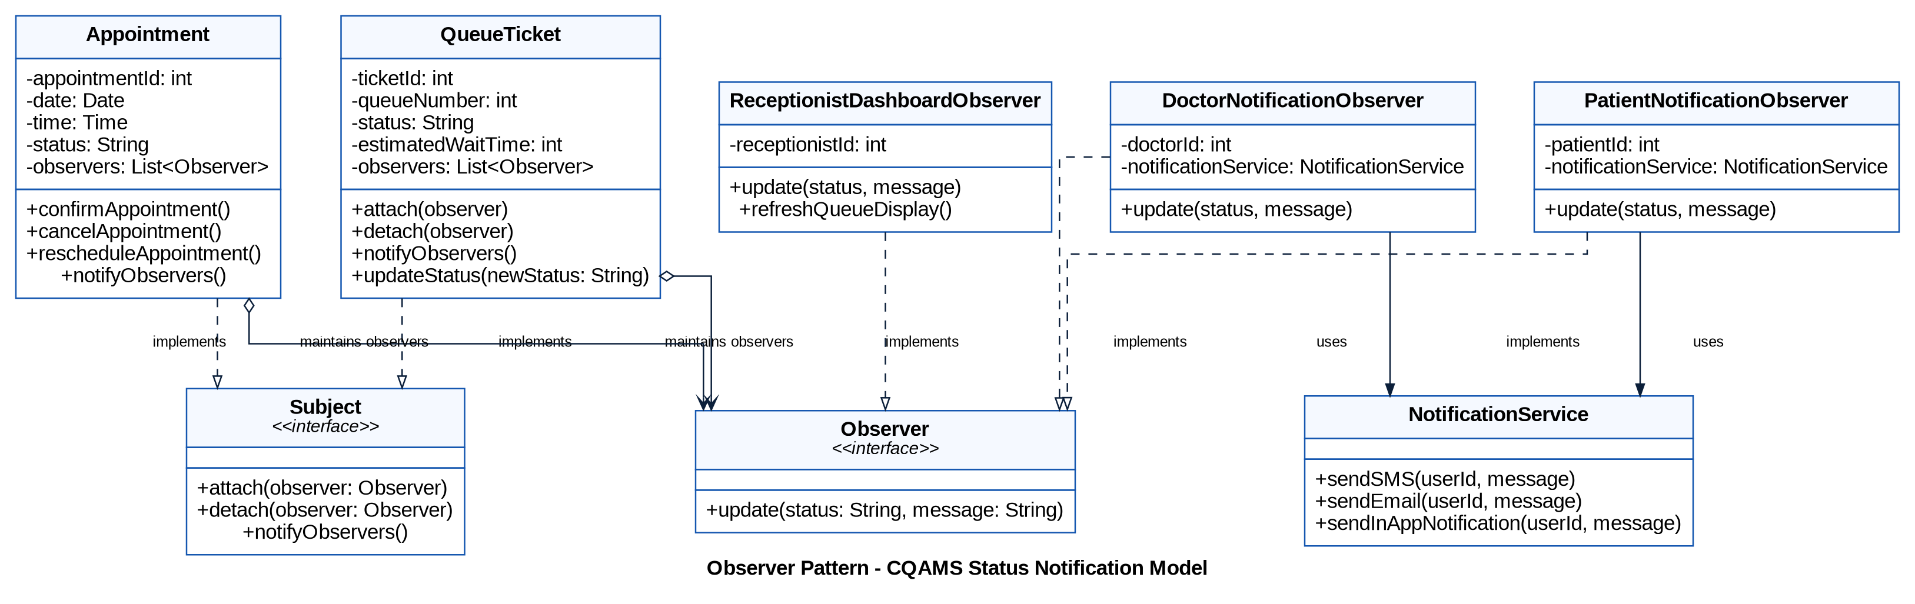
Figure 1. 1. Observer Pattern class diagram for CQAMS.

How the Pattern Improves the Design
It decouples status changes from notification delivery, so new observers can be added without modifying QueueTicket or Appointment logic.

2. Factory Method Pattern
Used for role-based user creation.

Justification in CQAMS
The Factory Method Pattern is appropriate because CQAMS manages different user roles: Patient, Doctor, Receptionist, and Administrator. These users share common attributes through the abstract User class, but each role has its own responsibilities and data. A patient books appointments, a doctor updates medical records, a receptionist manages walk-in patients, and an administrator manages users and reports. The Factory Method centralizes object creation and prevents the registration logic from being filled with repeated if/else statements. This makes the design cleaner and allows new roles to be added later with minimal changes.

Main Classes in the Pattern
User, Patient, Doctor, Receptionist, Administrator, UserFactory, PatientFactory, DoctorFactory, ReceptionistFactory, AdministratorFactory, RegistrationService, UserData.

Class Diagram
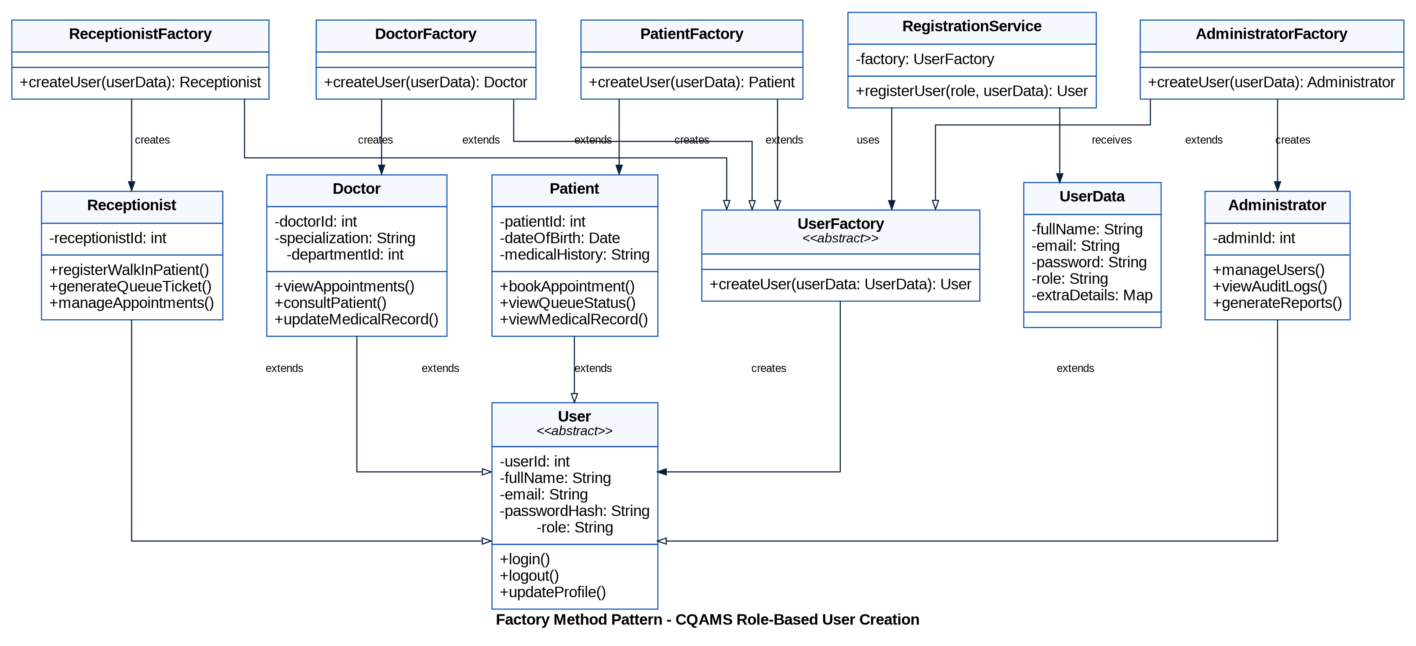
Figure 2. 2. Factory Method Pattern class diagram for CQAMS.

How the Pattern Improves the Design
It centralizes the creation of role-based users and reduces duplicated construction logic across the registration process.

3. Strategy Pattern
Used for flexible queue prioritization rules.

Justification in CQAMS
The Strategy Pattern fits CQAMS because the clinic may not always use the same queue ordering rule. In normal cases, patients can be handled using a first-come-first-served strategy. However, emergency cases may need higher priority, and scheduled patients may need to be ordered according to their appointment time. Instead of hardcoding one queue algorithm into the QueueManagementSystem, the Strategy Pattern allows the system to switch between different queue prioritization strategies depending on clinic policy. This makes the queue module more adaptable and realistic.

Main Classes in the Pattern
QueuePriorityStrategy, FirstComeFirstServedStrategy, EmergencyPriorityStrategy, AppointmentTimeStrategy, QueueManagementSystem, QueueTicket, Patient, Doctor.

Class Diagram
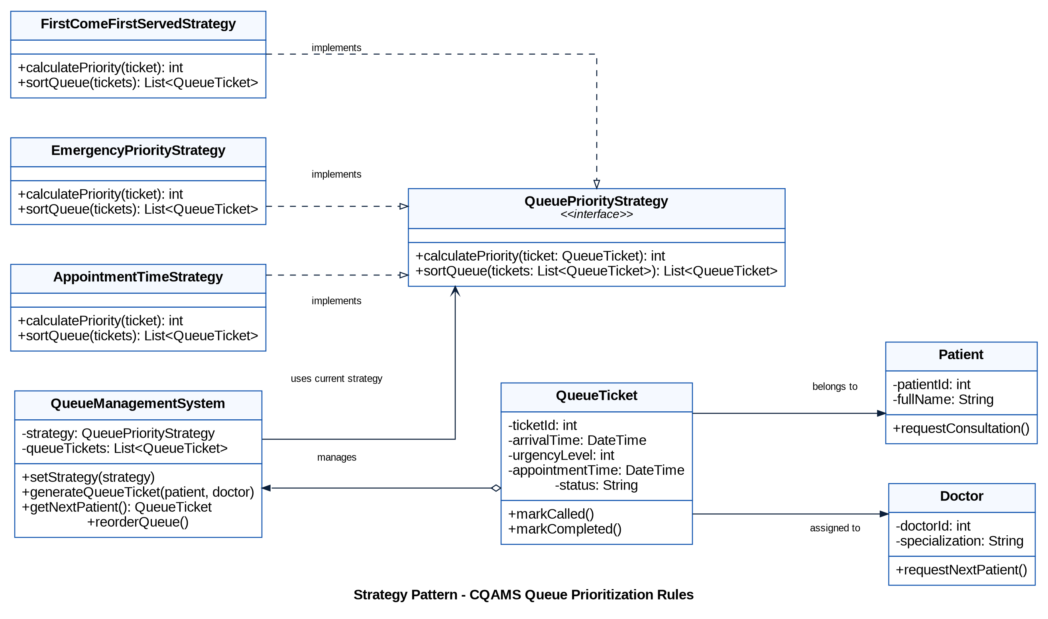
Figure 3. 3. Strategy Pattern class diagram for CQAMS.

How the Pattern Improves the Design
It allows queue prioritization rules to change without rewriting the QueueManagementSystem.

4. State Pattern
Used for controlling the queue ticket lifecycle.

Justification in CQAMS
The State Pattern is useful because QueueTicket objects move through a defined lifecycle. A ticket may be Waiting, Called, In Consultation, Completed, or Cancelled. Each state allows only certain actions. For example, a waiting ticket can be called or cancelled, a called ticket can move to consultation, and a ticket in consultation can be completed. Placing all this logic inside one large QueueTicket class would make the class difficult to maintain. With the State Pattern, each state class controls the behavior allowed in that specific status, making transitions clearer and reducing invalid status changes.

Main Classes in the Pattern
TicketState, WaitingState, CalledState, InConsultationState, CompletedState, CancelledState, QueueTicket, QueueManagementSystem.

Class Diagram
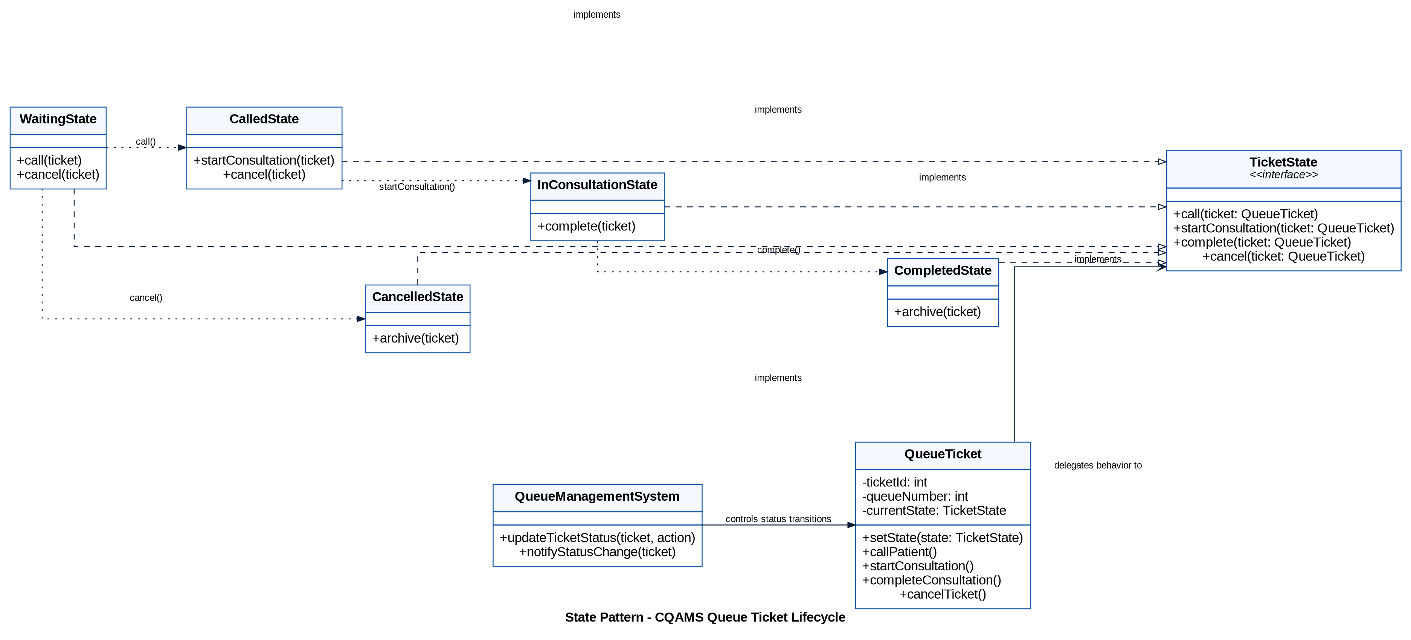
Figure 4. 4. State Pattern class diagram for CQAMS.

How the Pattern Improves the Design
It prevents invalid status transitions and keeps lifecycle behavior organized in separate state classes.

5. Facade Pattern (Bonus)
Used to simplify complex clinic workflows.

Justification in CQAMS
The Facade Pattern is a strong bonus pattern for CQAMS because many user actions require several internal services. For example, booking an appointment may involve checking availability, creating an appointment, updating status, and sending a confirmation. Registering a walk-in patient may involve creating or retrieving a patient profile, generating a queue ticket, assigning a doctor, and sending a notification. A ClinicWorkflowFacade provides a simplified interface to these internal services, so the user interfaces do not need to directly coordinate every subsystem. This improves readability and separates workflow orchestration from individual service logic.

Main Classes in the Pattern
ClinicWorkflowFacade, ReceptionistUI, PatientPortal, DoctorDashboard, PatientService, AppointmentService, QueueService, MedicalRecordService, NotificationService.

Class Diagram
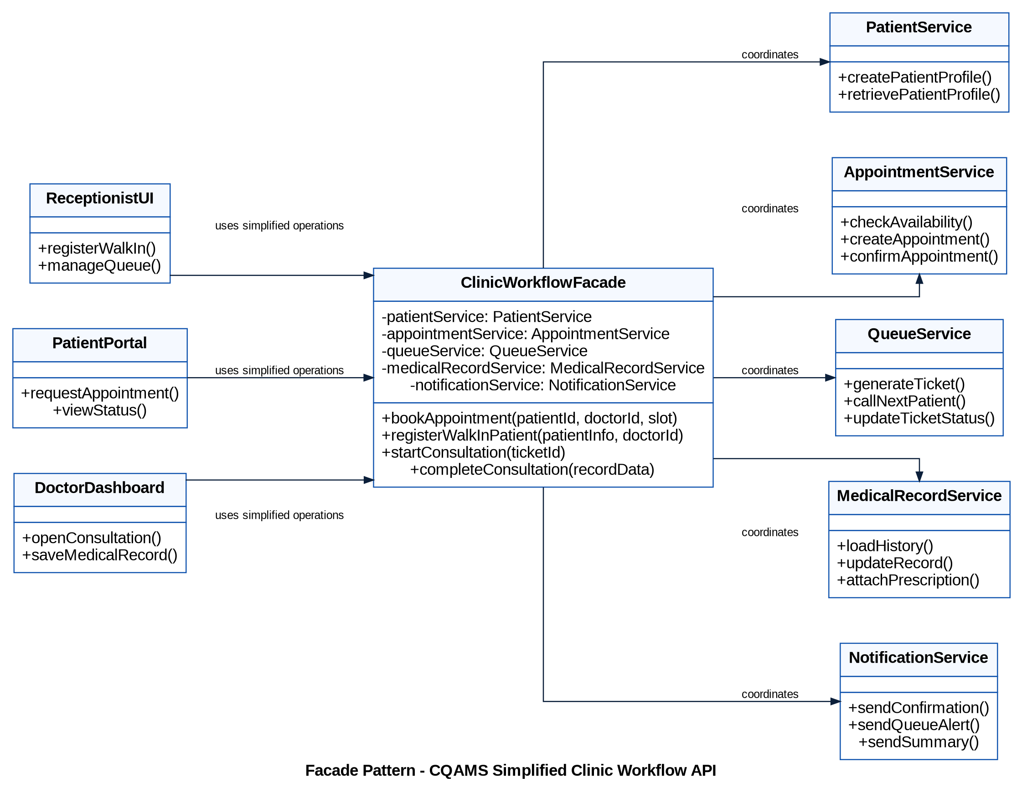
Figure 5. 5. Facade Pattern (Bonus) class diagram for CQAMS.

How the Pattern Improves the Design
It hides subsystem complexity behind one clean interface used by the patient portal, receptionist UI, and doctor dashboard.

Conclusion
The selected design patterns strengthen the CQAMS architecture by separating responsibilities and making the system easier to extend. Observer supports automatic updates, Factory Method organizes role-based user creation, Strategy provides flexible queue prioritization, State controls ticket lifecycle transitions, and Facade simplifies complex workflows. Together, these patterns demonstrate that CQAMS is not only modeled around functional requirements, but also designed with maintainability and scalability in mind.

Final Checklist
- Five design patterns are provided: four required and one bonus.
- Each pattern includes a CQAMS-specific justification paragraph.
- Each pattern includes one dedicated class diagram.
- All class diagrams use project-relevant classes and responsibilities.
- The patterns are connected to real CQAMS modules: notifications, user registration, queue management, lifecycle control, and workflow simplification.

References
Gamma, E., Helm, R., Johnson, R., & Vlissides, J. (1994). Design Patterns: Elements of Reusable Object-Oriented Software. Addison-Wesley.
Sommerville, I. (2016). Software Engineering (10th ed.). Pearson.
Booch, G., Rumbaugh, J., & Jacobson, I. (2005). The Unified Modeling Language User Guide (2nd ed.). Addison-Wesley.

